# Homework nr 5 – ex. 2

## Chereji Iulia group 912/1

***Graph nr1:***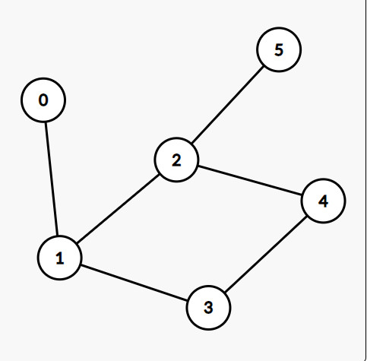

Input file:

6 6  
0 1  
1 2  
1 3  
2 4  
2 5  
3 4

Minimum vertex cover: (0, 2, 3) -> length: 3

***Graph nr2:***

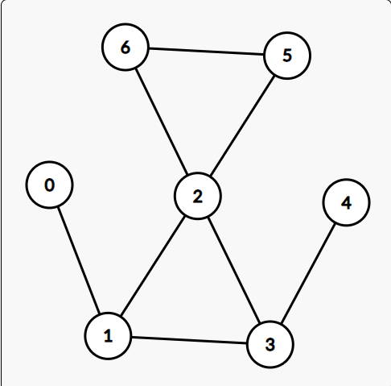

Input file:

7 8  
0 1  
1 2  
1 3  
2 3  
2 5  
2 6  
3 4  
5 6

Minimum vertex cover: (0, 2, 3, 5) -> length: 4